Biological Motion from Second-order and Motion-Energy Cues

Azim Chyngozhoev, Oh-Sang Kwon

Department of Biomedical Engineering, College of Information and Biotechnology, Ulsan National Institute of Science and Technology, Ulsan, Republic of Korea

|  |  |  |
| --- | --- | --- |
| KEYWORDS |  | ABSTRACT |
| Biological Motion  Point-light Walkers  First-order vs. Second-order Motion  Motion-energy  Eccentricity  Peripheral vision  Direction discrimination  Adaptive staircase |  | The perception of biological motion (BM) generally depends on high-contrast point-light walkers (PLWs). However, natural environments feature motion signals characterized by contrast boundaries or texture flow, which may be processed in a distinct manner, particularly outside the fovea. We investigated how the type of cue and retinal eccentricity together affect left–right direction discrimination. Nine participants observed PLWs displayed in three formats: first-order luminance dots (FO), second-order contrast apertures (SO), and motion-energy carriers (ME). A 3-up/1-down staircase method at 10° eccentricity adjusted the 'Squish' (dot-trajectory scaling) to each participant's threshold of 75–85%. Utilizing these individually calibrated stimuli, participants undertook 144 trials for each cue × eccentricity combination (0°, 10°, 20°). Accuracy and confidence were averaged for each participant and analyzed using a 3 × 3 repeated-measures ANOVA. Accuracy decreased with increasing eccentricity, F(2, 20) = 28.0, p < .001, and varied by cue type, F(2, 20) = 63.1, p < .001, with a significant interaction observed, F(4, 40) = 10.4, p < .001. FO walkers maintained high accuracy (0.99 → 0.94 → 1.00), while SO accuracy dropped by 43 percentage points (0.92 → 0.78 → 0.49) and ME accuracy plummeted to 0.28 at 20°, significantly below chance levels (t = 6.0, p < .0002), indicating a systematic misperception rather than random guessing. Confidence levels mirrored accuracy for FO and SO cues, however ME showed robust high confidence even with the significant decline in accuracy. These results indicate that first-order cues facilitate strong BM perception throughout the visual field, while second-order and motion-energy cues deteriorate sharply beyond parafoveal vision. The findings support a model suggesting that peripheral BM recognition relies on high-level form templates, with local second-order integration and carrier motion becoming increasingly disrupted by larger receptive fields. Future research should increase the subject sample, and investigate clinical populations with peripheral deficits. |

# Introduction

Humans possess the ability to recognize intricate actions from merely a few moving dots—a phenomenon initially demonstrated by Johansson in 1973. These point-light walkers (PLWs) are generally depicted using high-contrast (‘first-order’) luminance dots, which exhibit strong and clear local motion signals. However, in typical visual perception, motion can also be characterized by contrast-modulated apertures (‘second-order’ cues) or by the motion of carrier textures confined within static windows (‘motion-energy’ cues). Consequently, performance with second-order cues deteriorates more significantly in peripheral vision, and at elevated temporal frequencies, observers may even perceive a reversal in direction (Thompson 2007). Nevertheless, few studies have examined all three cue types within the same biological-motion task, and almost none have done so while rigorously controlling gaze. The current study addresses this gap. By employing gaze fixation control, we assessed left–right direction discrimination for PLWs represented as first-order (FO), second-order (SO), and motion-energy (ME) walkers at eccentricities of 0°, 10°, and 20°.

# Past Literature

Foundational research conducted by Johansson (1973) initially demonstrated that observers can easily recognize biological motion from sparse luminance-defined point-light displays, therefore establishing a benchmark for future studies. A comprehensive synthesis by Blake and Shiffrar (2007) validated the effectiveness of this first-order pathway and emphasized the visual system’s dependence on global form cues to interpret human movement. Going beyond luminance signals, Gurnsey, Poirier, and Denmark (2010) revealed that direction discrimination is still achievable when walkers are represented solely by second-order (contrast-modulated) information, although accuracy significantly declines, indicating less reliable underlying motion signals.

Collectively, these studies suggest that while first-order cues facilitate nearly optimal biological-motion perception, second-order cues are less effective and may ultimately rely on the same form-based templates. Our research builds upon this body of literature by directly comparing first- and second-order walkers—as well as motion-energy stimuli.

# Methods:

## 3.1 Participants

Nine adults (2 females, 7 males; 22–26 years, all with normal or corrected-to-normal vision) gave informed consent under the university ethics protocol. Data from every participant was retained.

## 3.2 Apparatus and Eye Fixation

Stimuli were presented on a 1440-Hz “PROPixx”  DLP LED projector (1920 × 1080 px) at 57 cm. A remote eye-tracker (Eyelink 1000 Plus) enforced central fixation: each trial began only when gaze lay within ±2° of a central cross, and trials with deviation > 2° were aborted and re-queued. The animation was 60FPS regardless of screen refresh rate.

## A two math equations AI-generated content may be incorrect.3.3 Stimuli

A Demo Video from biomotionlab.ca was taken and separated into 10 evenly spread frames using VLC player. Using ImageJ software, each dot was manually assigned their X and Y coordinates across 10 frames. Coordinates from 10 frames were interpolated using Python to recreate 60 frames. 1 gait cycle was equal to around 1 sec. (Figure 1)

Figure 1

Figure 2

Point-light walkers were rendered in three cue formats (figure 2):

| **Code** | **Cue** | **Implementation details** |
| --- | --- | --- |
| **FO** | *First-order luminance* | 13 black dots on grey background |
| **SO** | *Second-order contrast* | Each dot became a moving circular aperture revealing a static high contrast Gabor plaid; only the aperture moved |
| **ME** | *Motion-energy* | Static circular windows containing an high contrast Gabor Plaid carrier drifting with the corresponding dot’s biomechanical trajectory |

Walkers faced either left or right and were displayed at three retinal eccentricities (0°, 10°, 20° on the horizontal meridian) ether left or right from the fixation point.

## 3.4 Calibration Staircase

Before the main task each participant completed a **3-up/1-down adaptive staircase** at 10° eccentricity. The adjustable parameter was “*Squish*,” a linear vertical and horizontal compression that reduces walker’s ambiguity. Step size = 0.01for horizontal squishing and 0.015 for vertical squishing due to the fact that vertical squish was already short distance traveled, which needs a bigger step size to see a difference.

Minimum trials – 75, maximum trials – 100. The staircase terminated after subject reached 75-85% accuracy, at least 5 reversals in the last 20 trials and at least 10 reversals overall. With the SD of 0.075. The mean of the final 10 reversal levels served as that participant’s ambiguity threshold.

## 3.5 Main Experiment

A **3 (walker) × 3 (eccentricity)** within-subject design yielded nine conditions. Each participant completed **144 trials total**. Trial sequence:

1. 500 ms fixation cross (gaze-contingent).
2. 2 s walker animation.
3. 2-AFC prompt: “Left or Right?” (keyboard ← / →).
4. 5-point confidence rating (1 = guess, 3 = sure).

# Results

## 4.1 Calibration

Across participants the staircase converged as intended

Group **mean accuracy** = 79 %.

**Mean threshold** for SO = 0.854, ME = 0.863

**Stability**: SD of the final 10 reversals = 0.04 (group average).

**Reversals** achieved: Mean = 18 (range 16–21);

Figure 4 ME staircase calibration

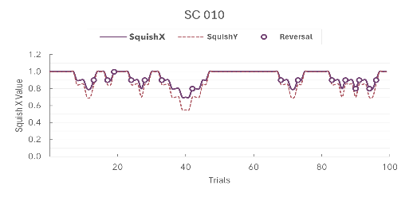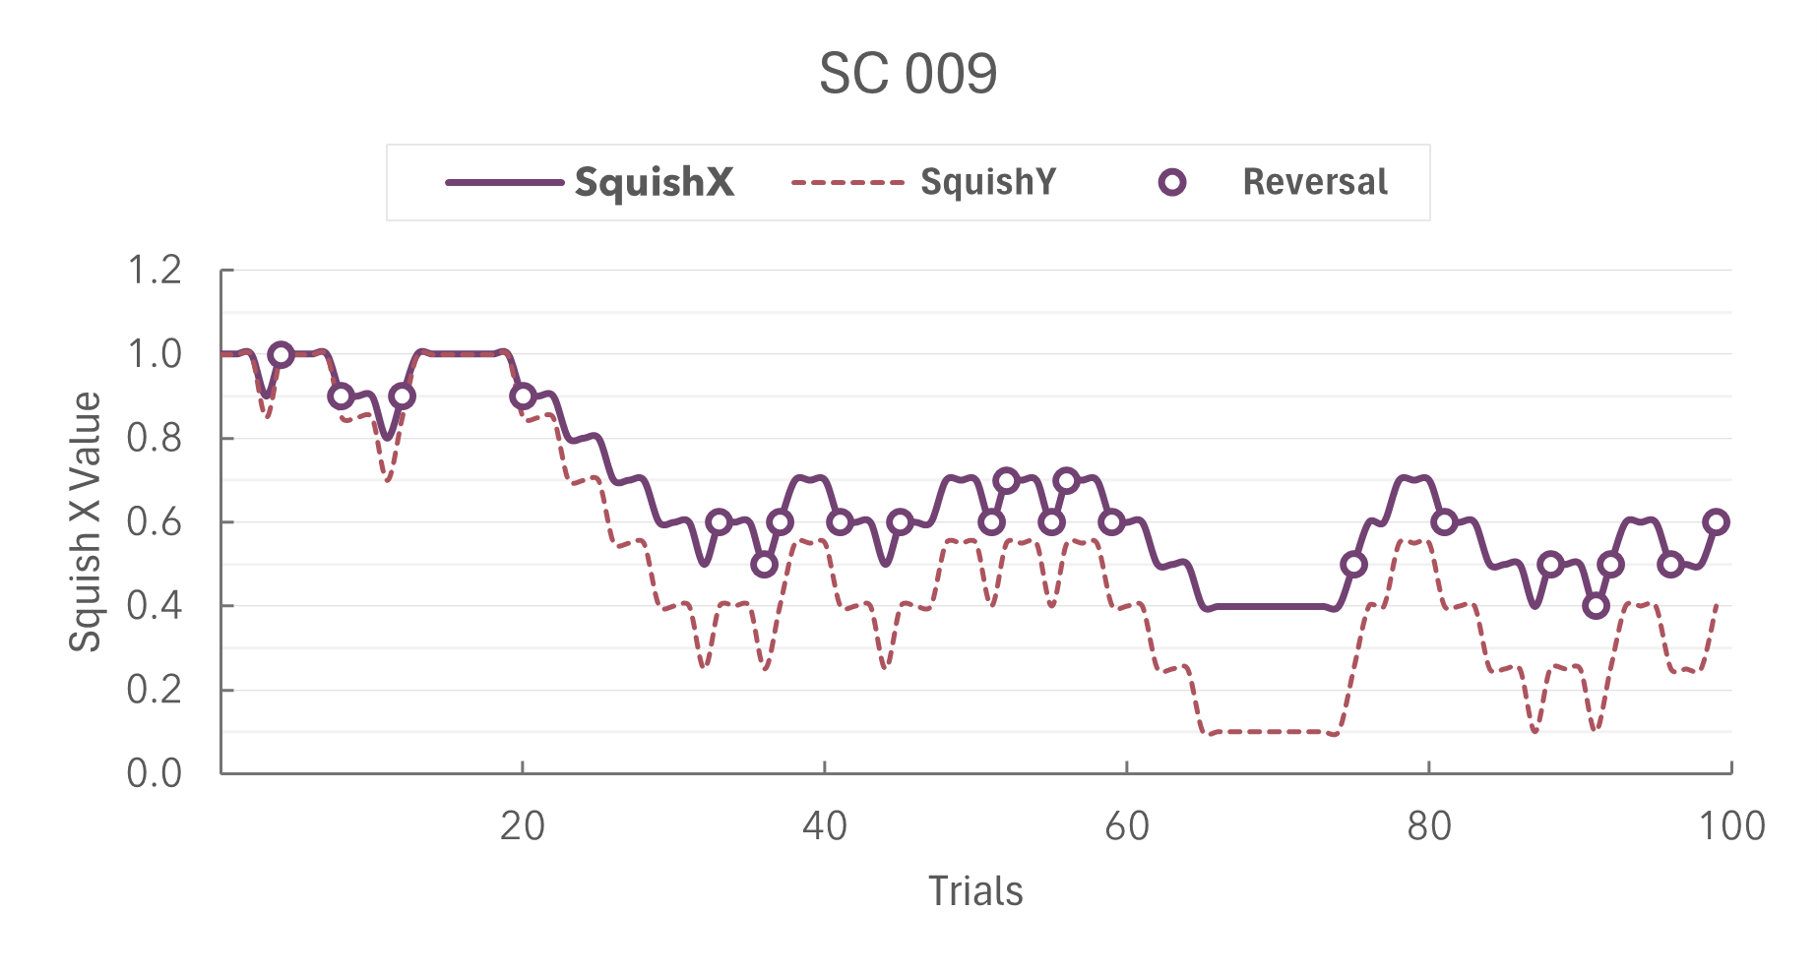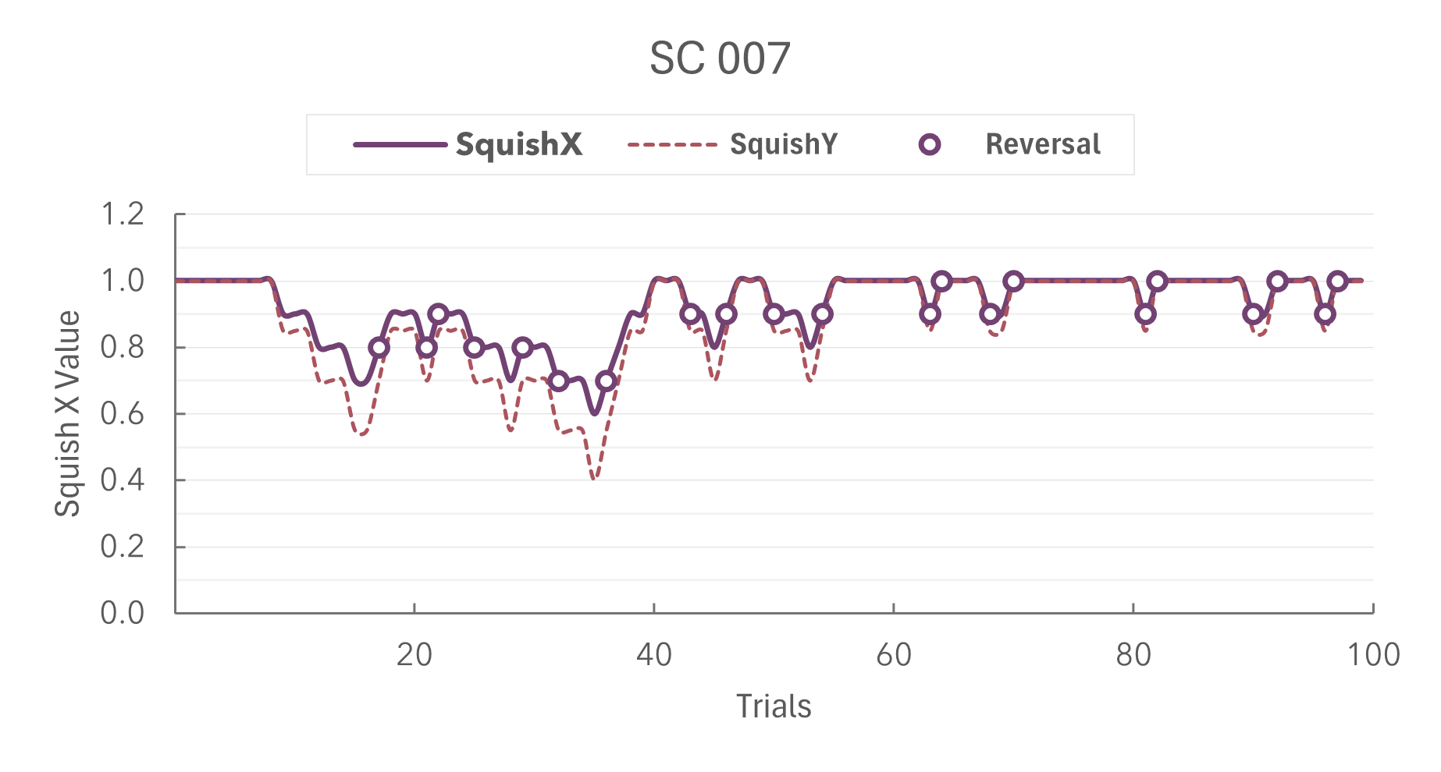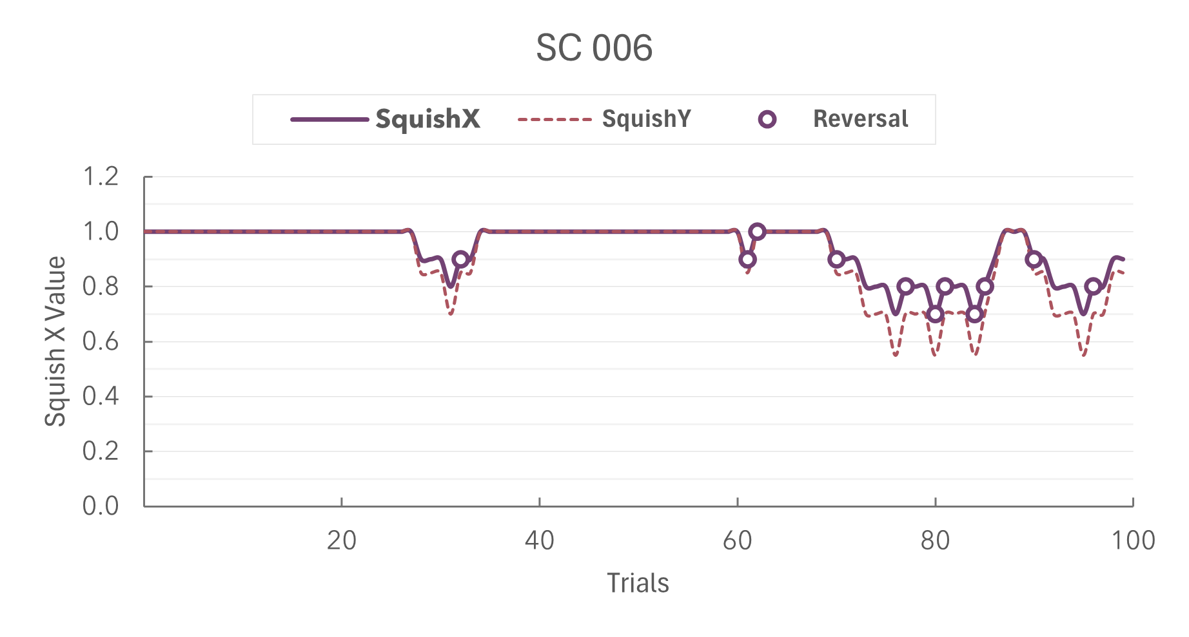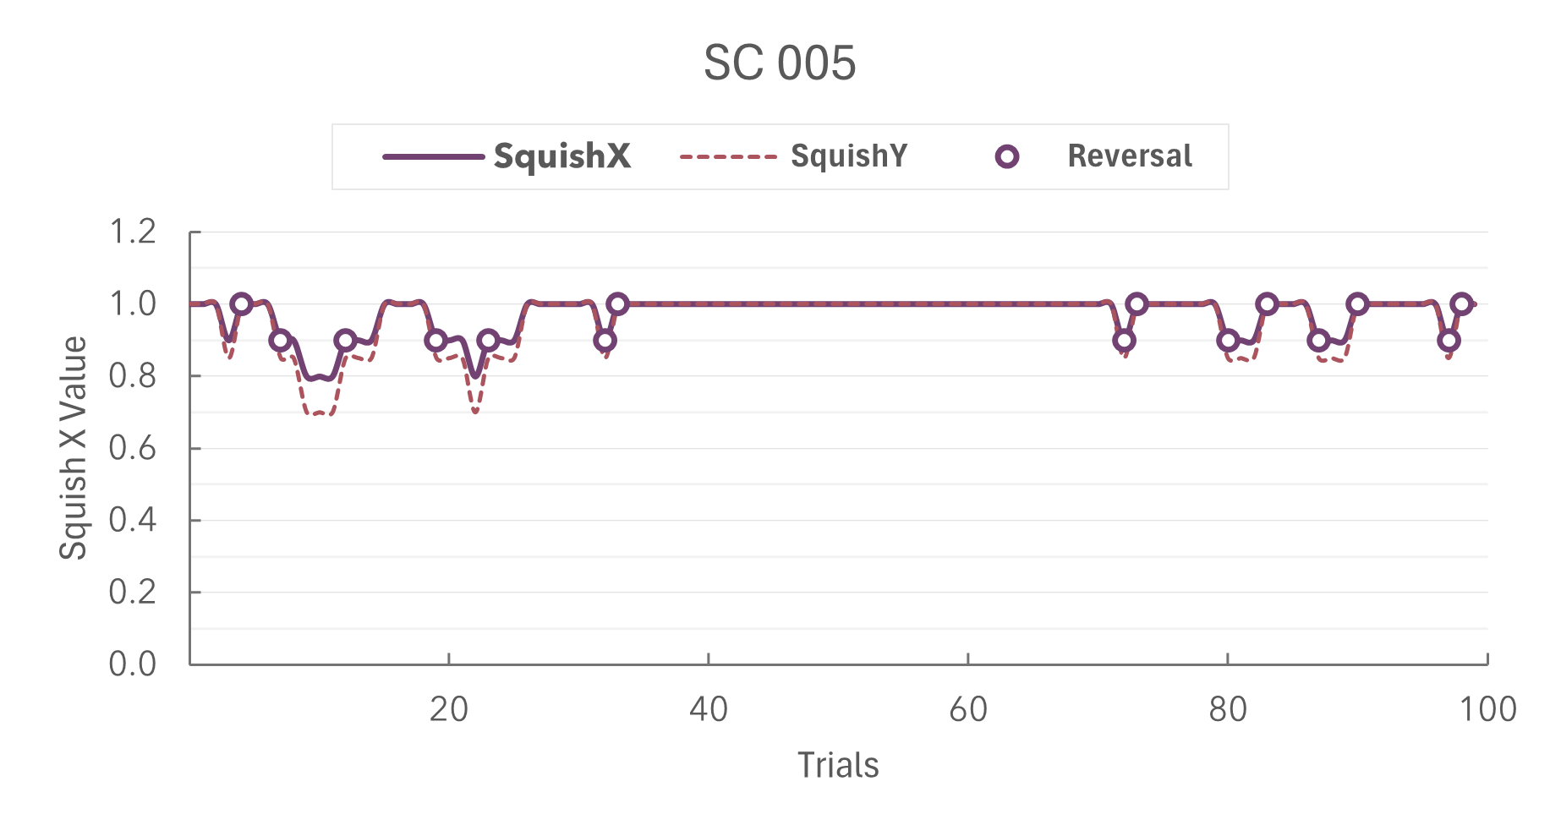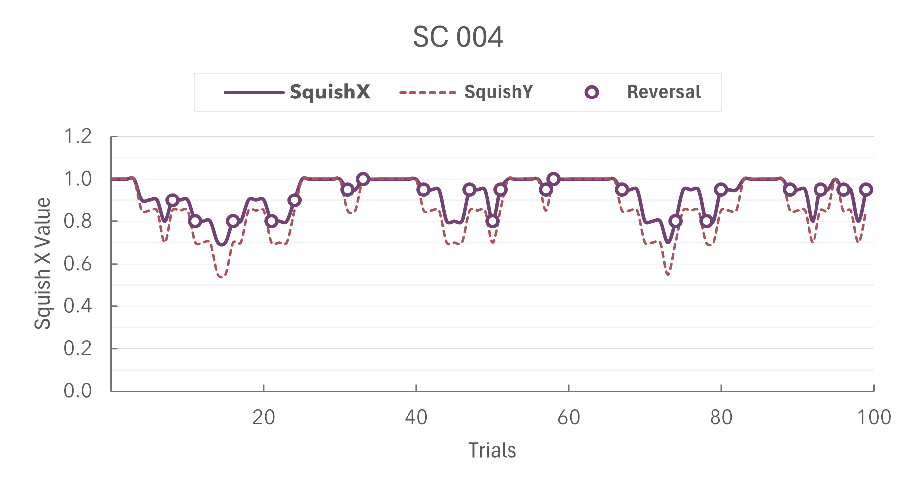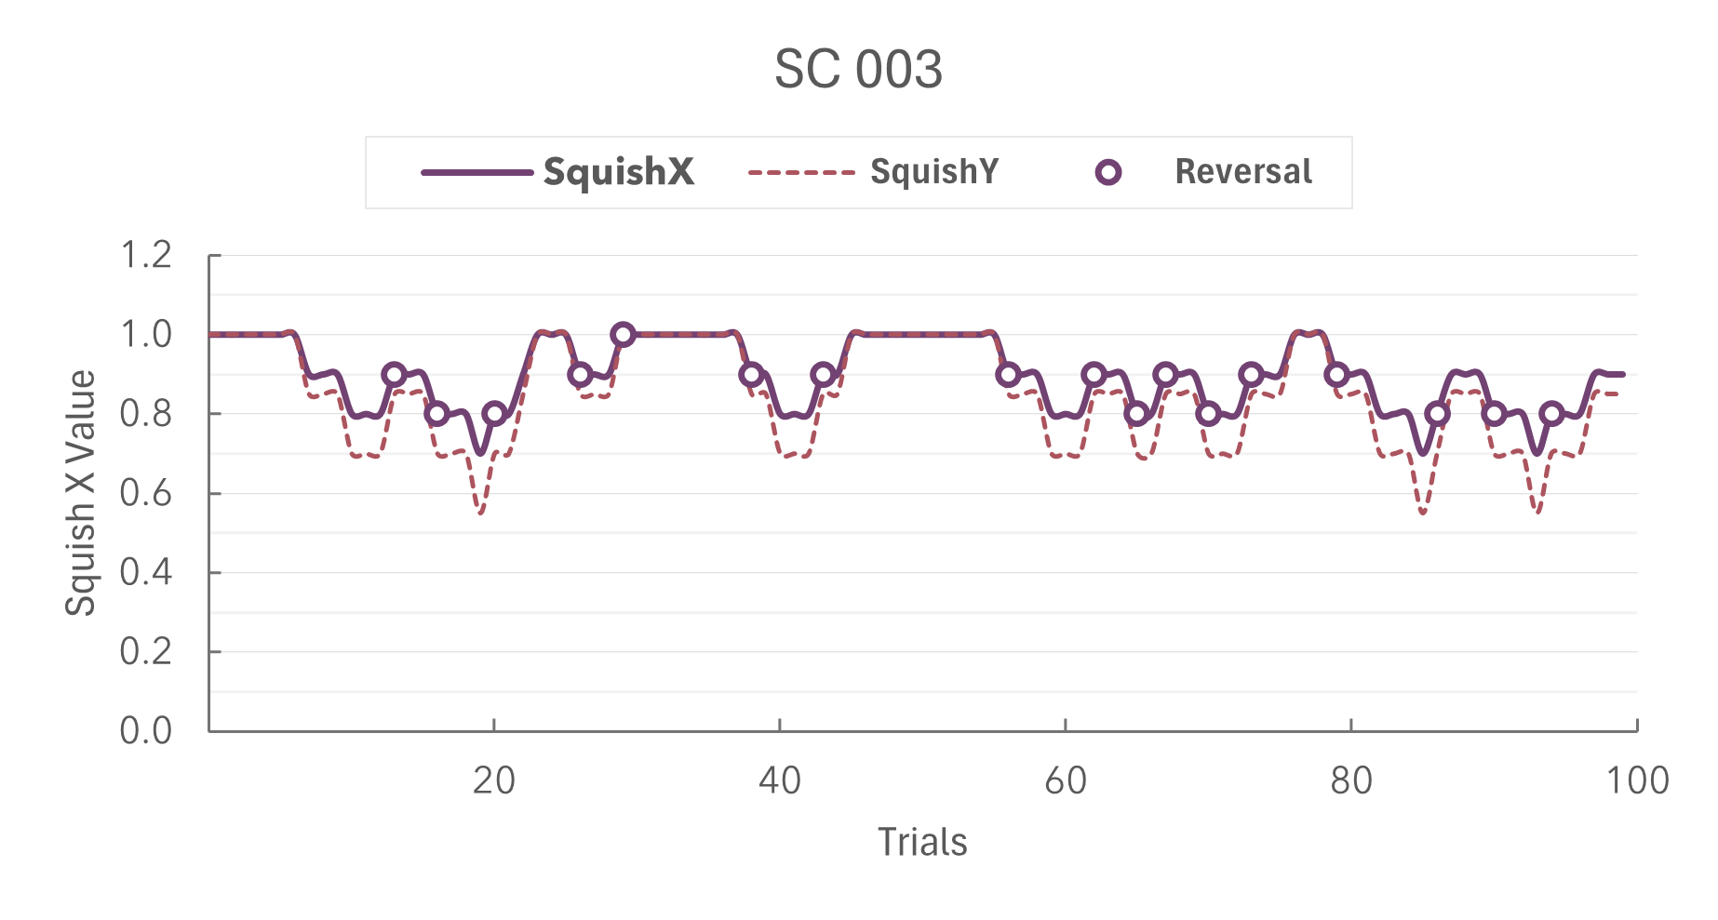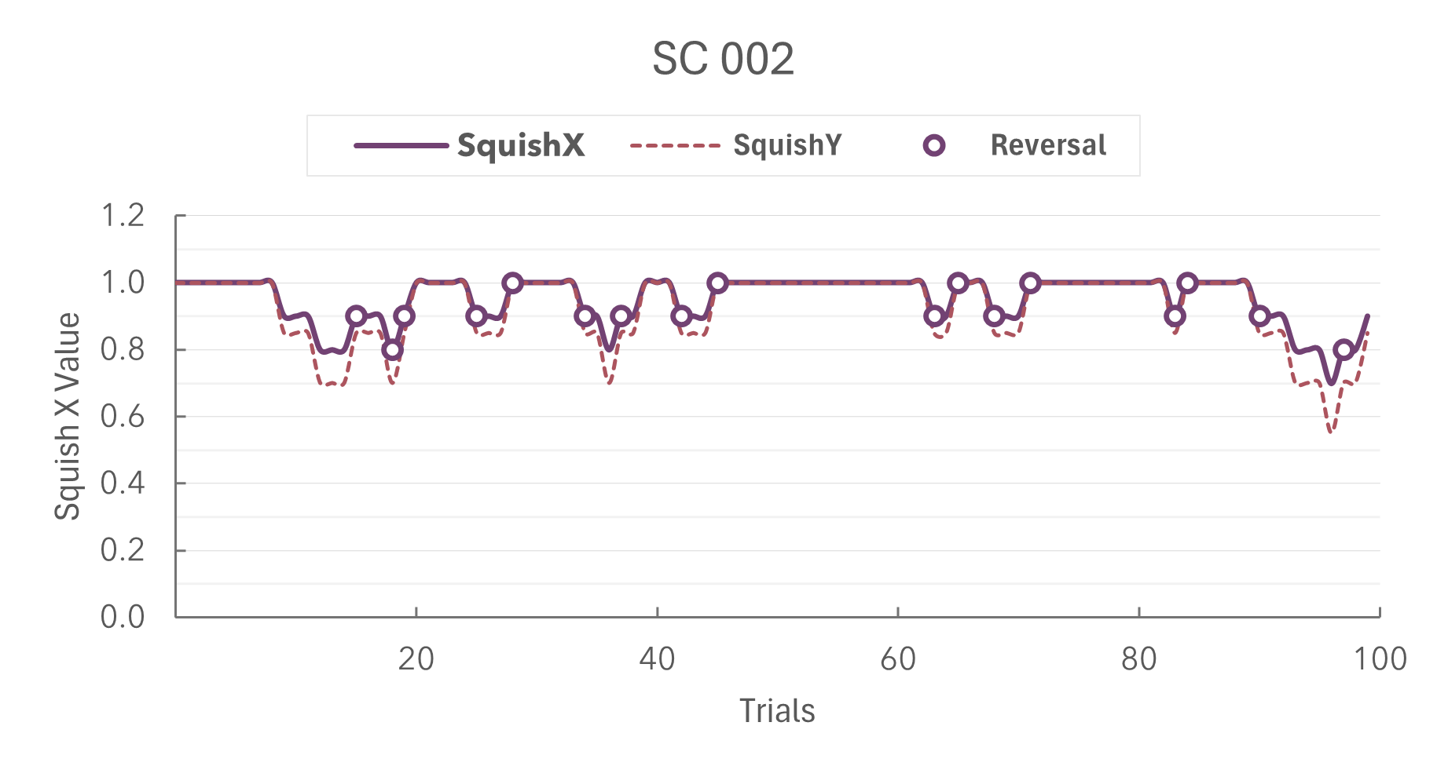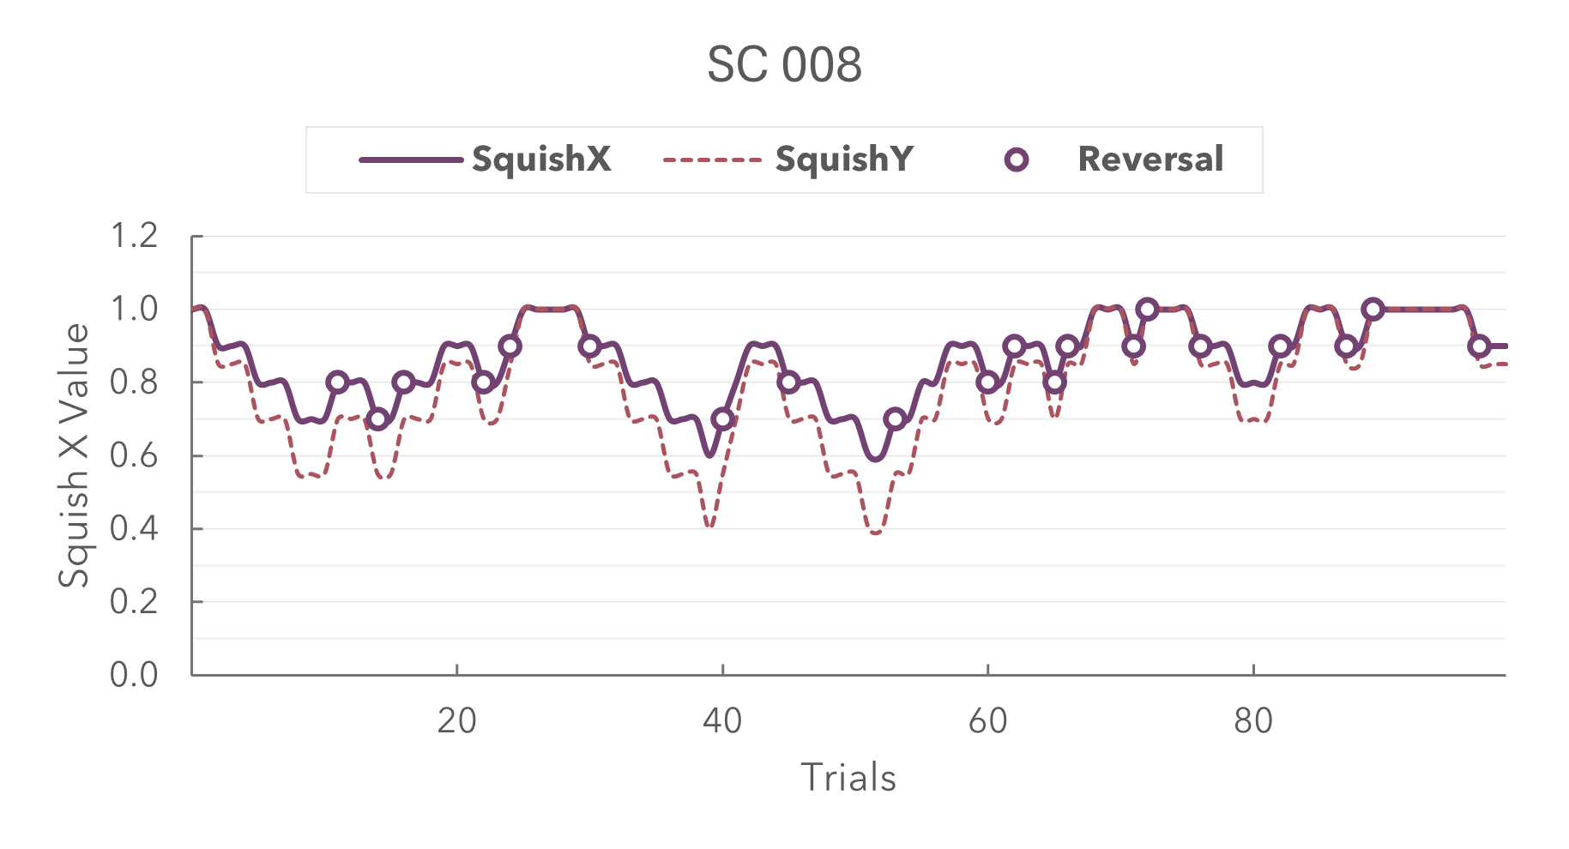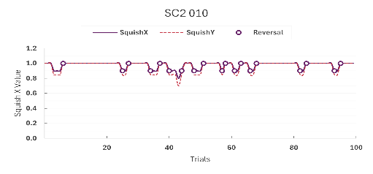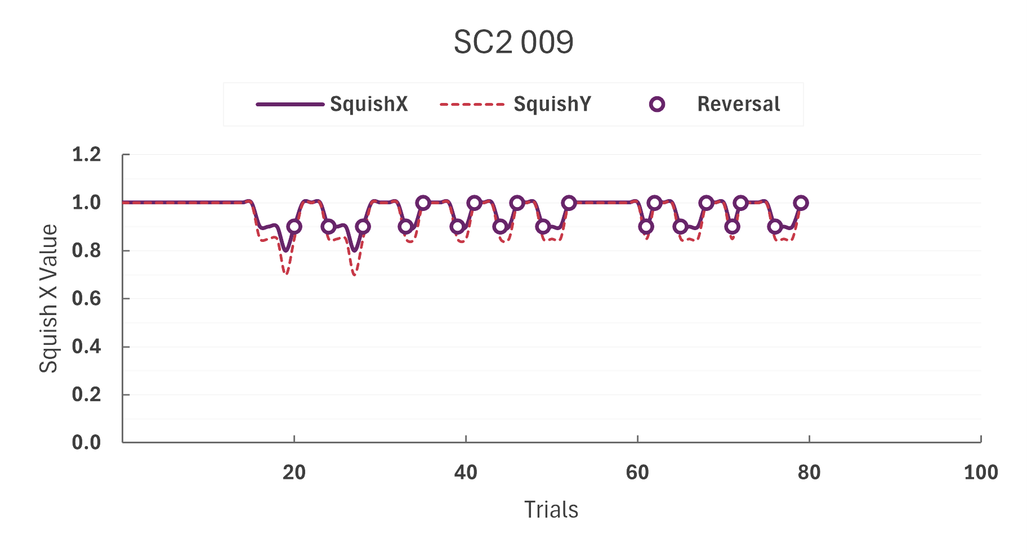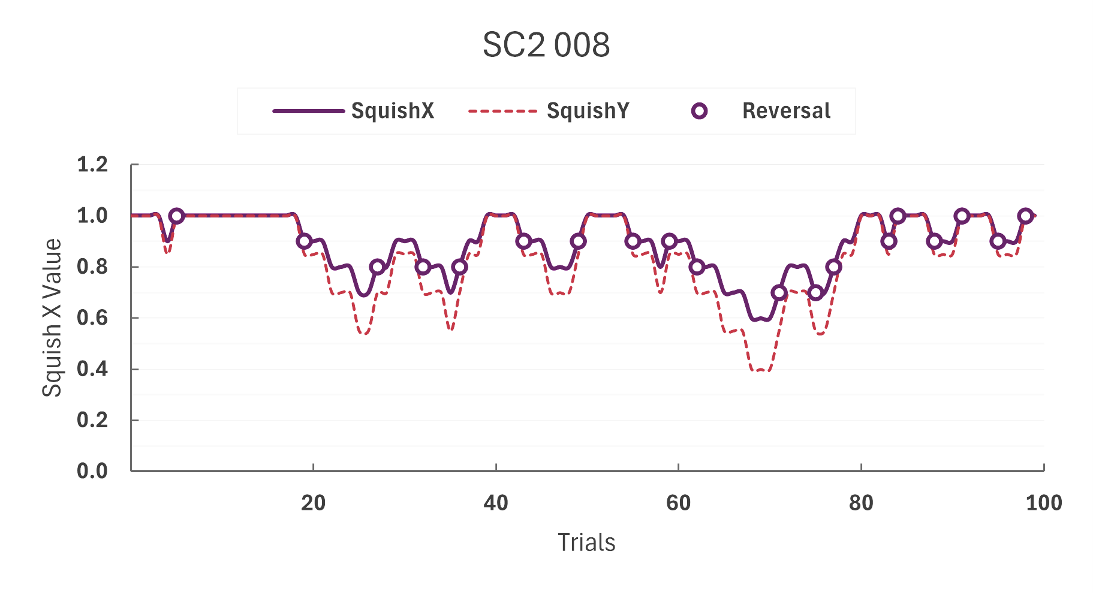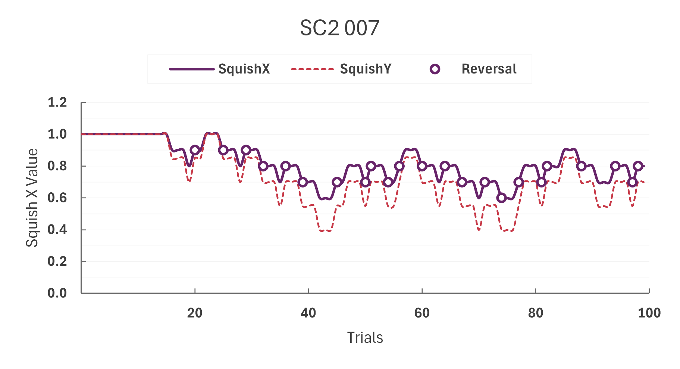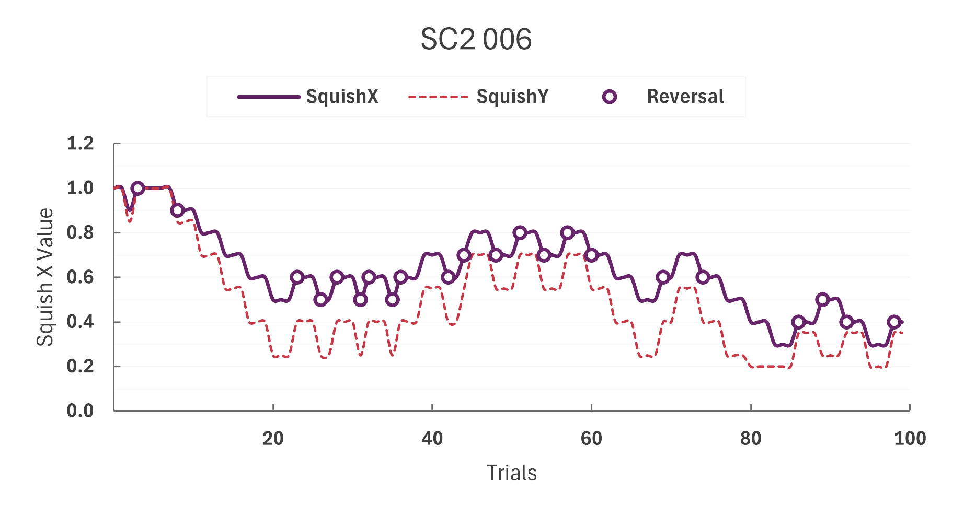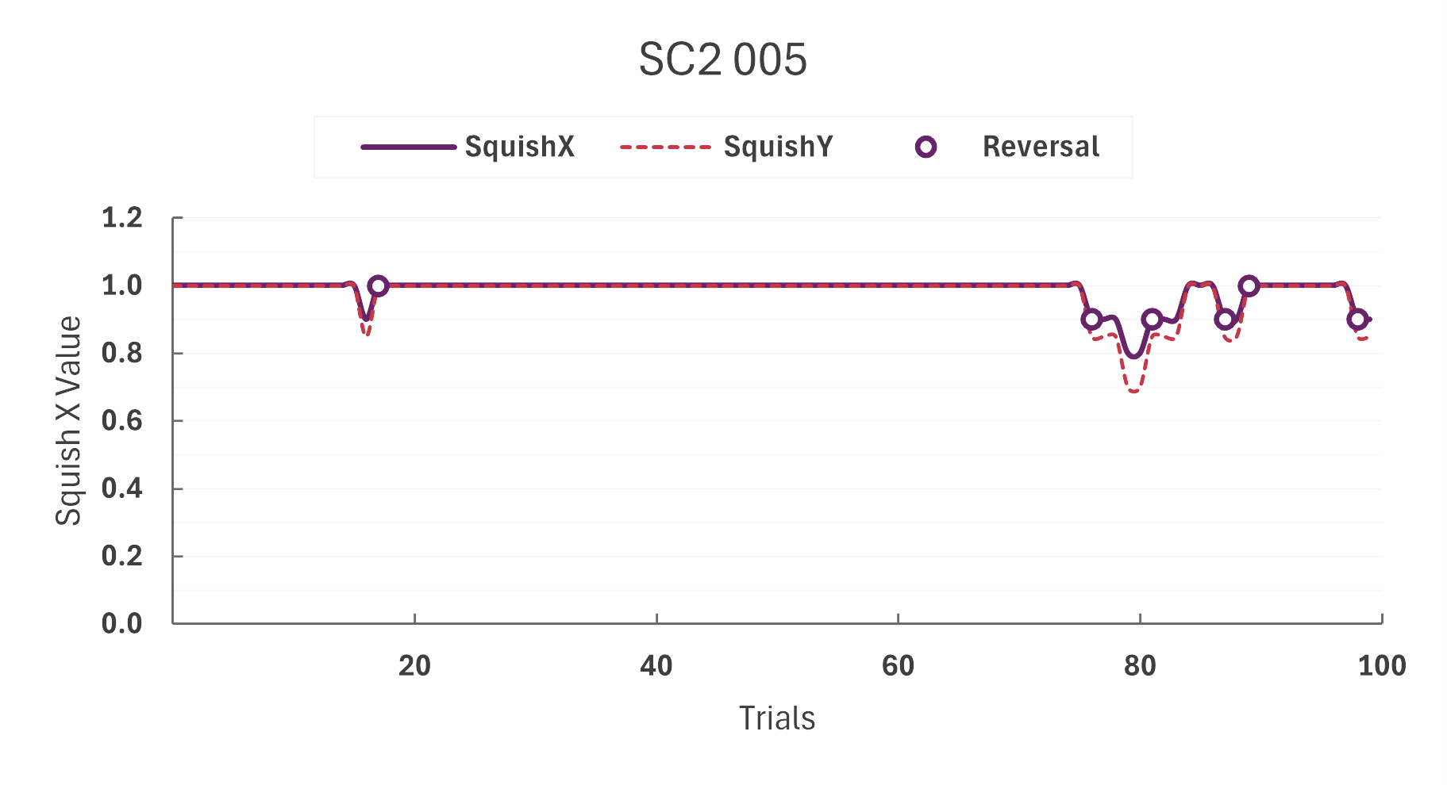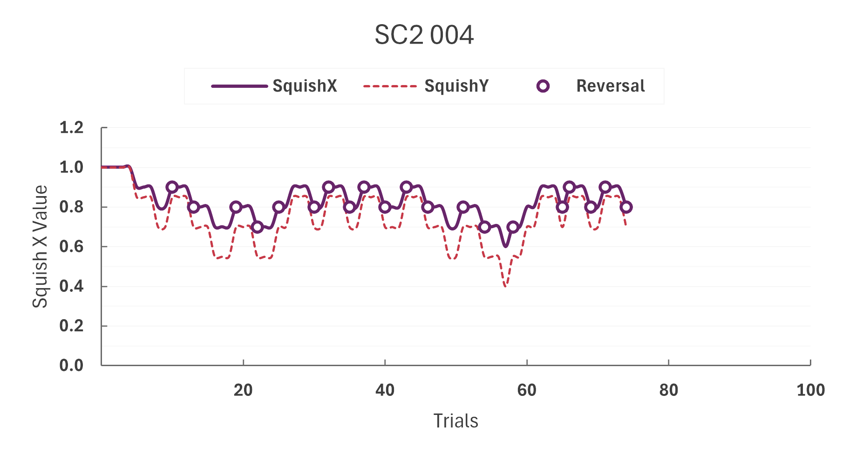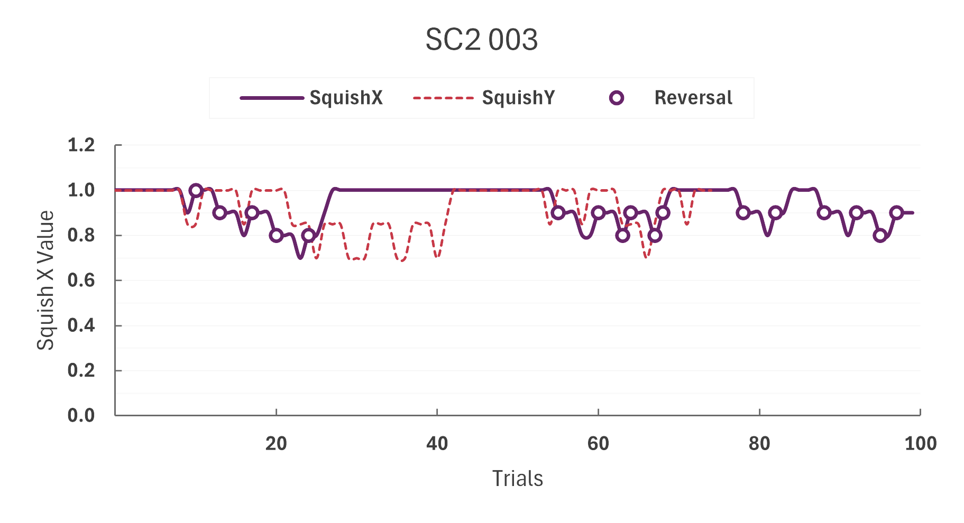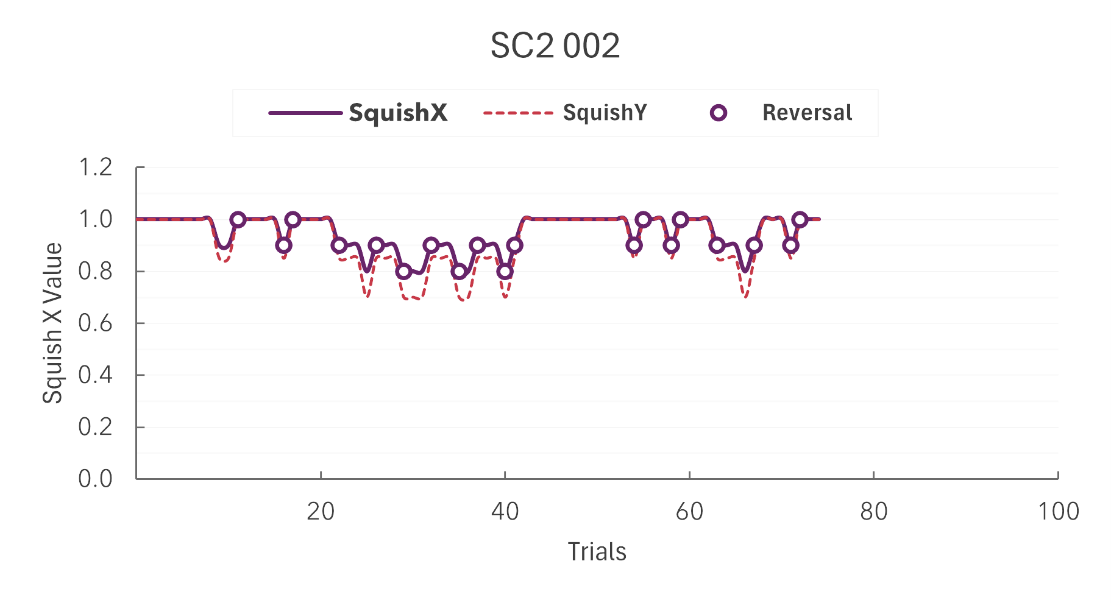

Figure 3 SO staircase calibration

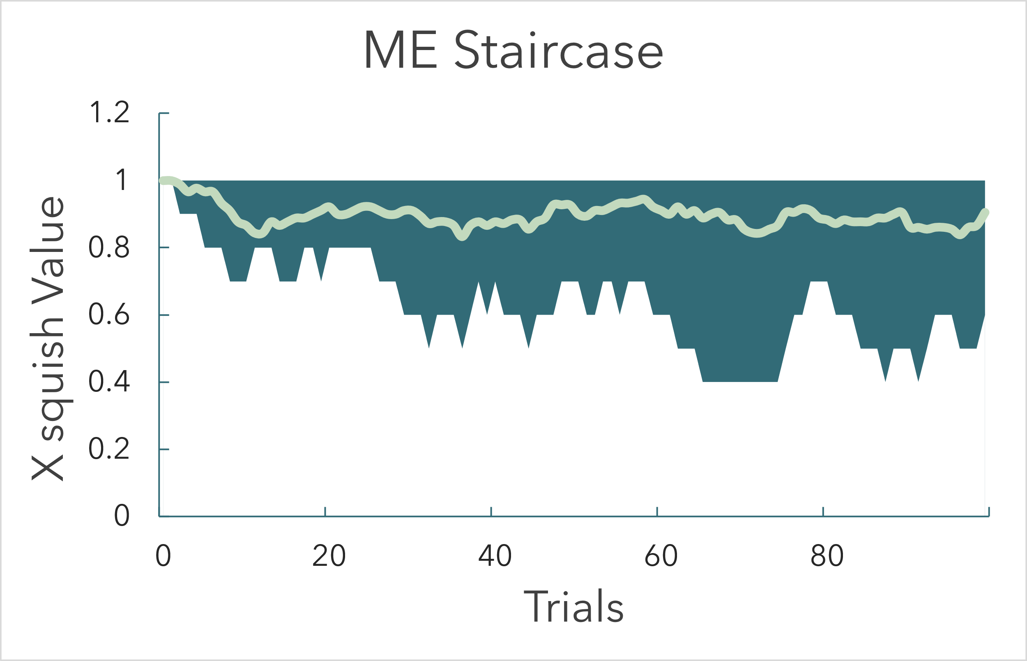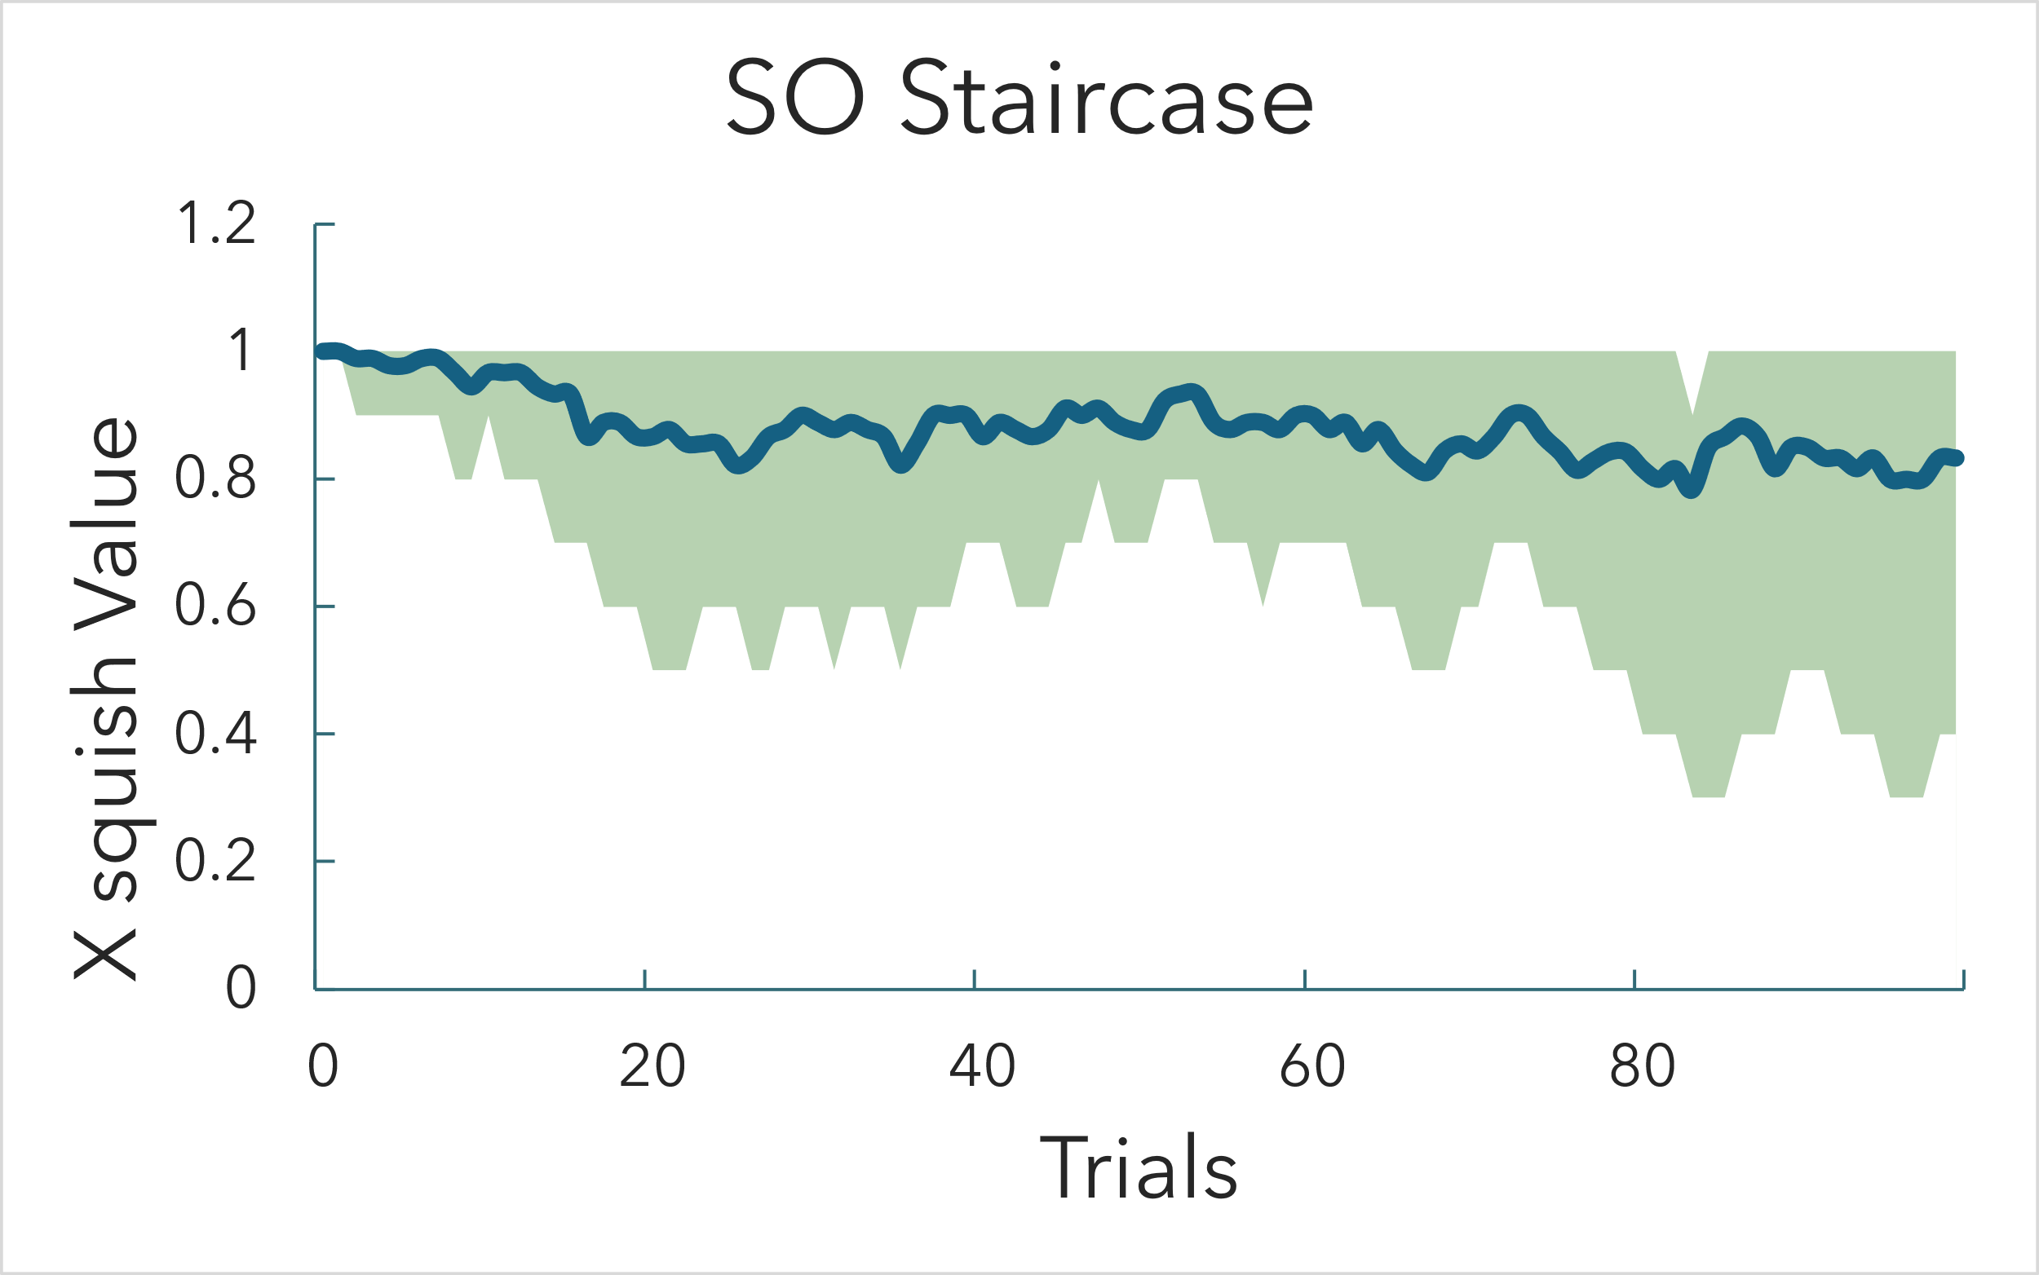Average staircase:

**4.2 Accuracy and Confidence (Main Experiment)**

|  |  |  |  |
| --- | --- | --- | --- |
| **Walker → / Eccentricity ↓** | **0°** | **10°** | **20°** |
| **FO** | .99 ± .02 | .94 ± .04 | **1.00 ± .00** |
| **SO** | .92 ± .05 | .79 ± .06 | **.49 ± .08** |
| **ME** | .92 ± .06 | .54 ± .07 | **.28 ± .07** |

*Values are M ± SEM (N = 9).*

* **Walker main effect:** *p* < .001
* **Eccentricity main effect:** *p* < .001
* **Walker × Eccentricity:** *p* < .001 for SO and ME

Post-hoc (Tukey): FO > SO > ME at every eccentricity (all *p* < .01).  
At 20° the ME condition fell **below chance**: pooled binomial test *p* < 10⁻⁷; one-sample *t*(8) = –6.0, *p* < .0002. This indicates systematic direction-reve rsal rather than guessing.

While FO condition stayed robust, participants showed a steep decline in both SO and ME conditions across periphery. First 2 subjects have 0% accuracy in ME condition at 20 degrees, but high confidence rating, showing a sign of genuine misperception. Although it was expected for FO to have 100% accuracy, we still observe some subjects making mistakes. After getting feedback from participants, it was said to be off putting and unexpected to have a FO appear at the center.

For ME condition PLWs Bars below 50 % (002, 003, 004, 006, 007, 009) indicate a systematic bias toward the wrong direction, not random guessing. This participant-by-participant consistency strengthens the claim that carrier-based motion cues can invert perceived direction when viewed parafoveally.

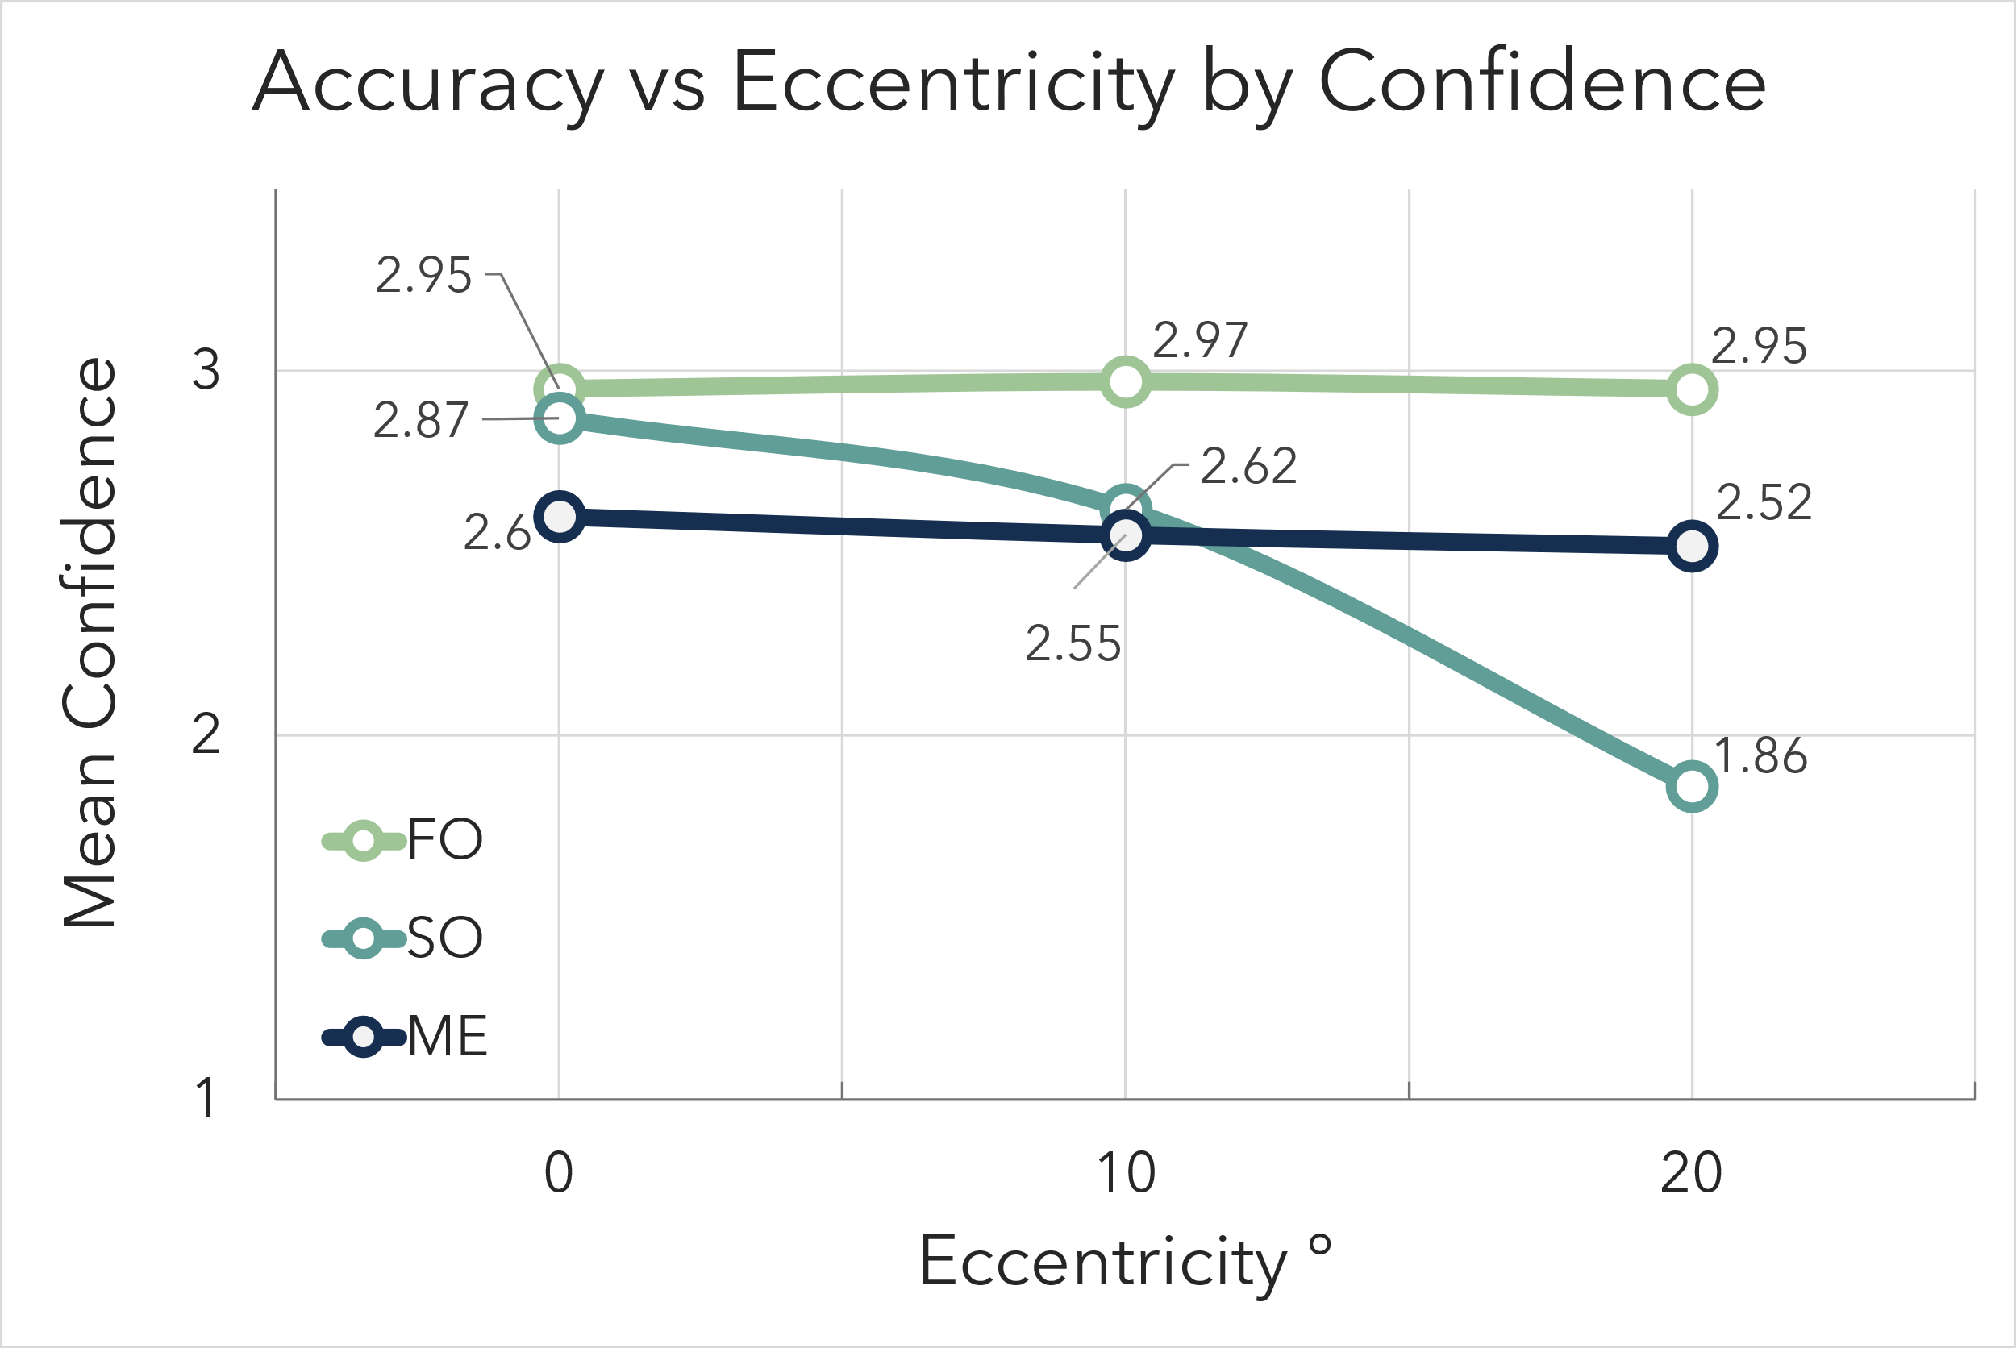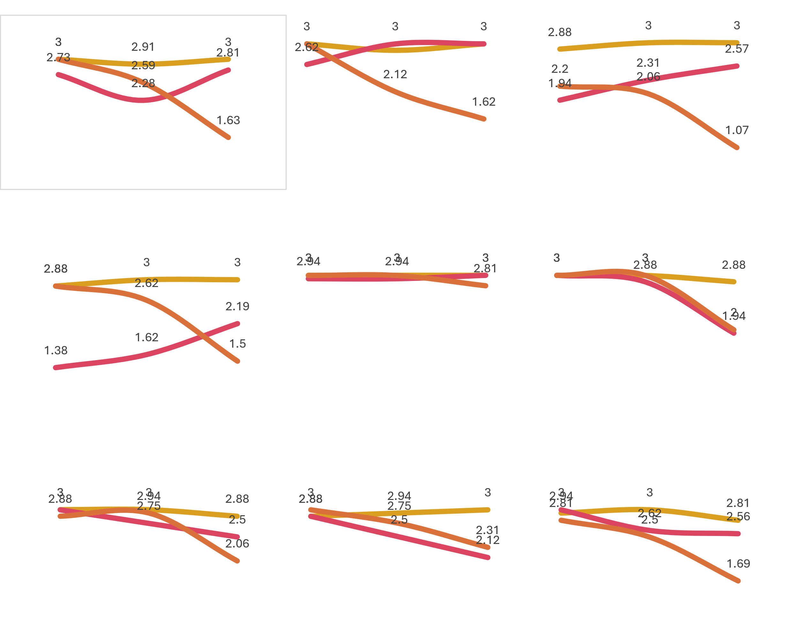Confidence ratings for both FO and SO decline with eccentricity increase. However, ME shows that confidence decreases at 10degrees but increases at 20degrees.

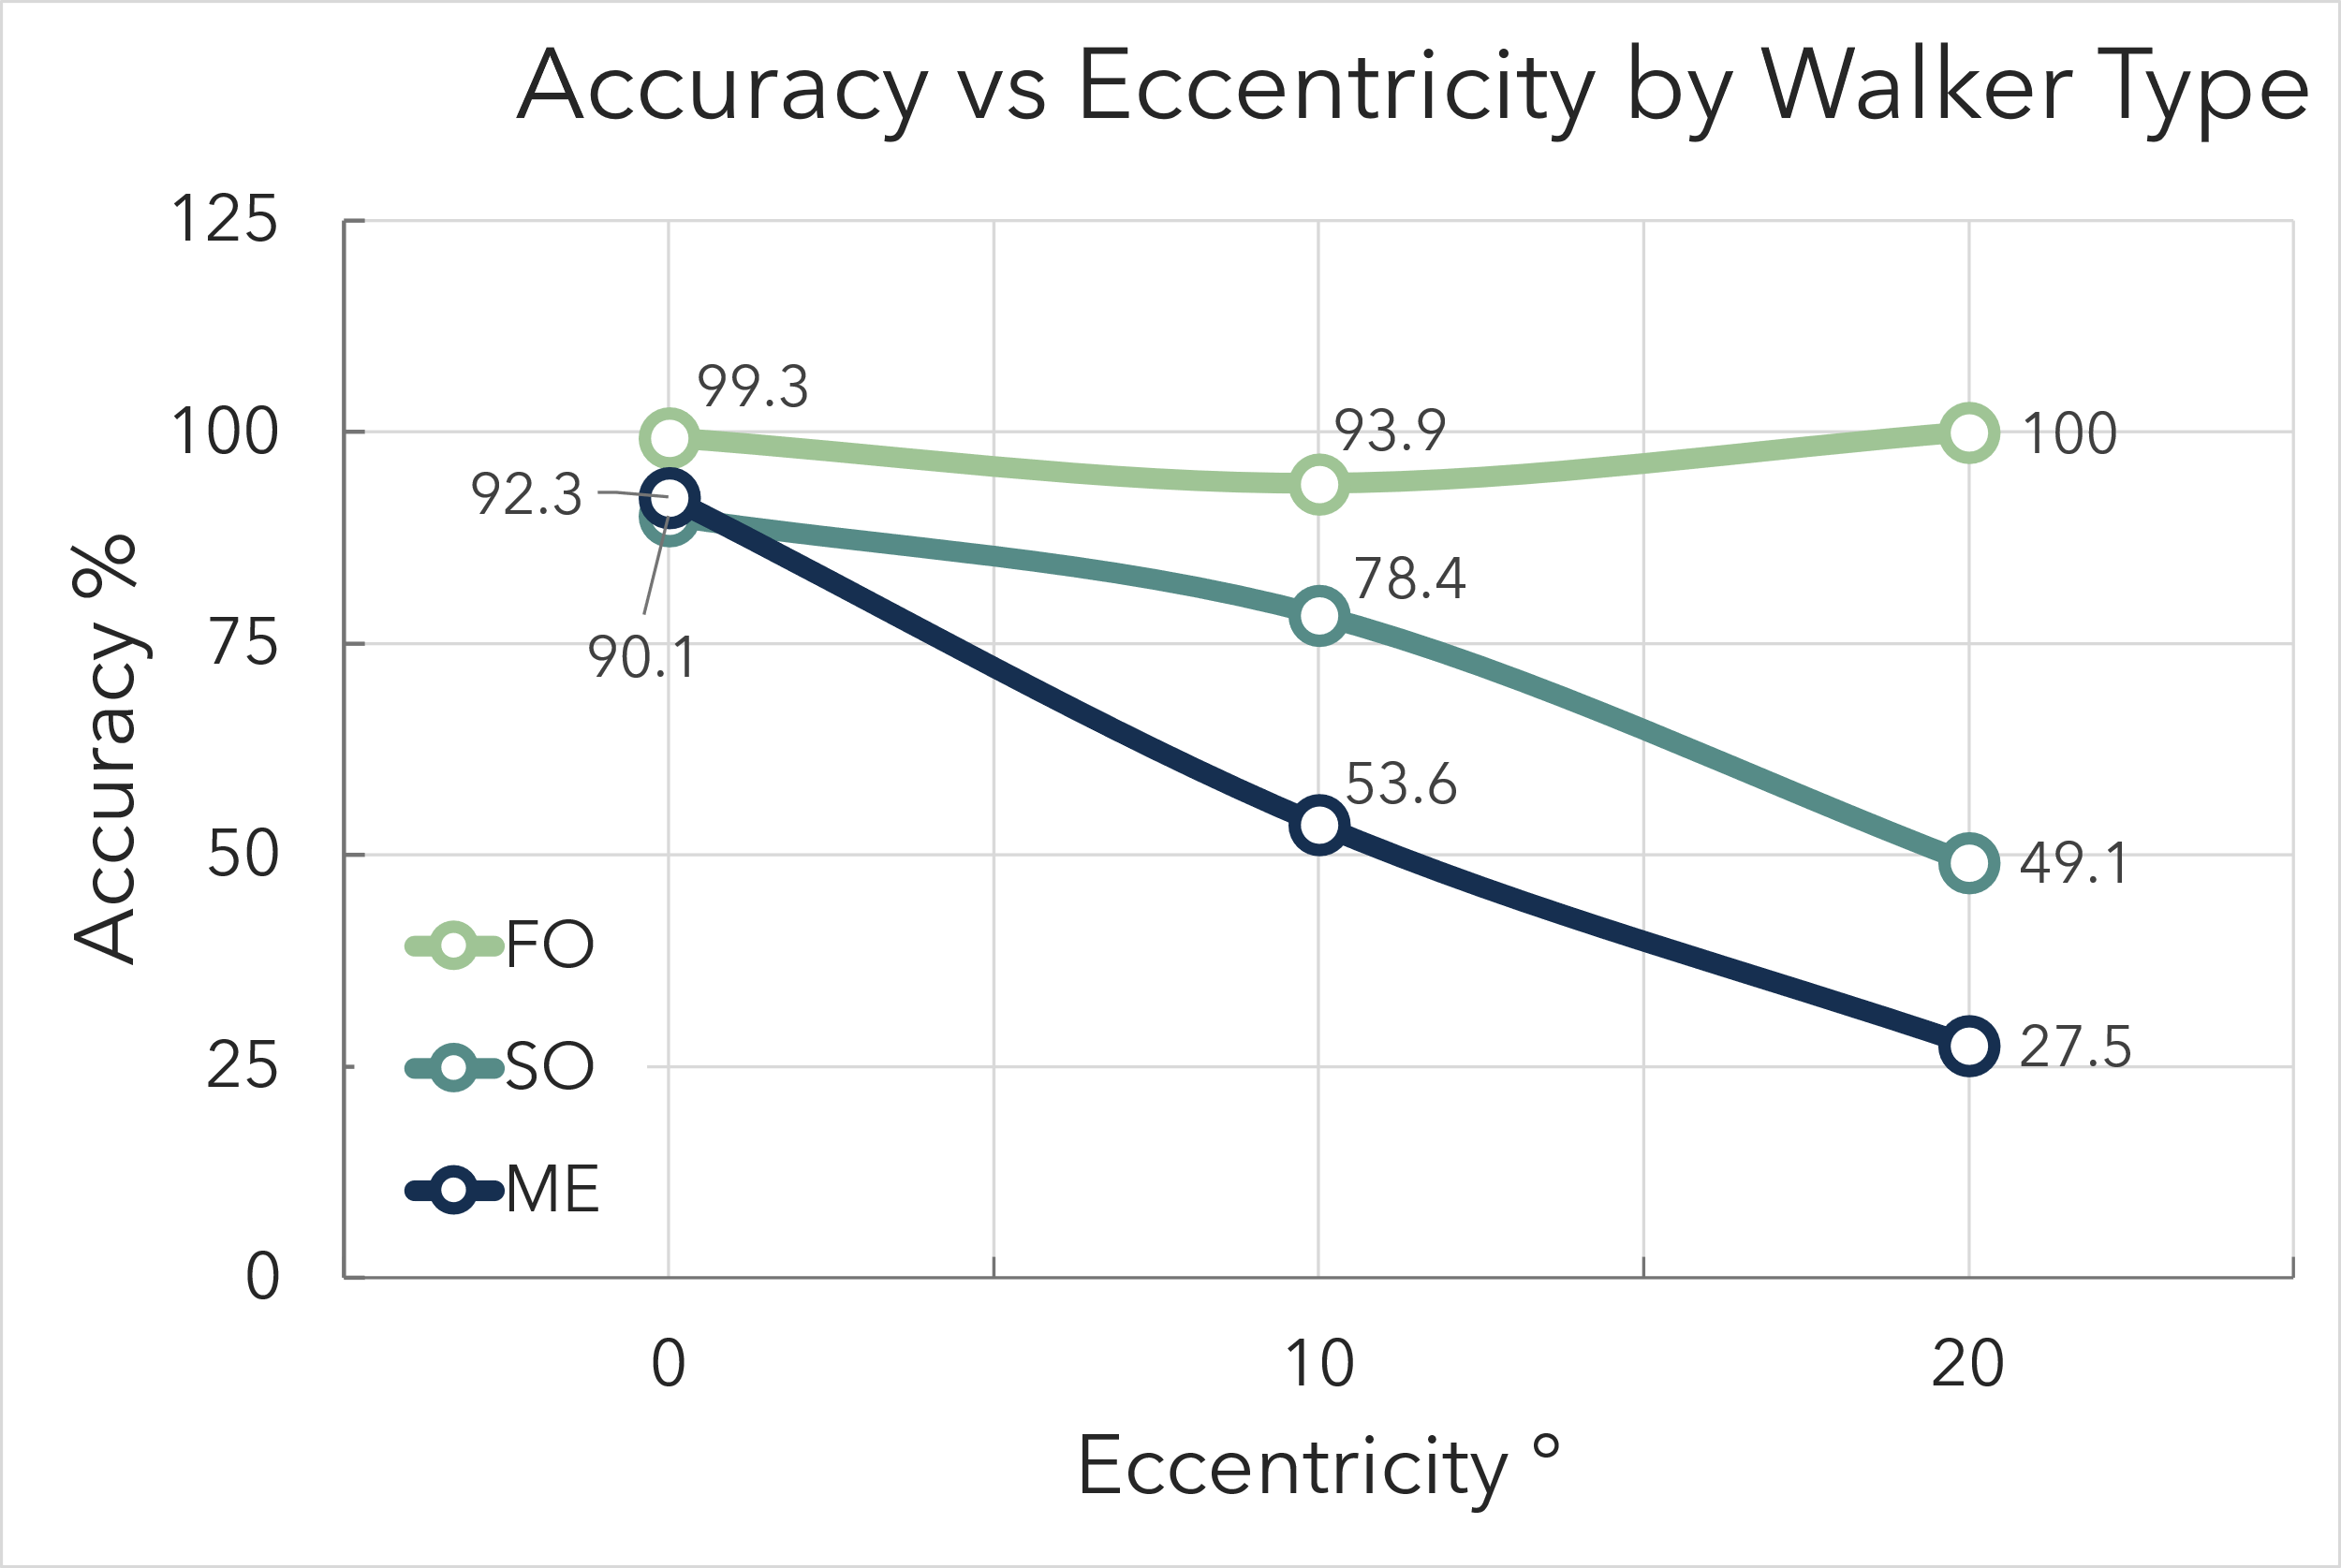This may reveal a new insight into motion detection. Subjects appear to be confident in their decision but are always wrong, meaning a genuine misperception is taking place. 

If we look at significance levels, it is not significantly lower that 50%, meaning subjects are guessing, but after leave-one-out subject significance, it shows a highly significant difference.

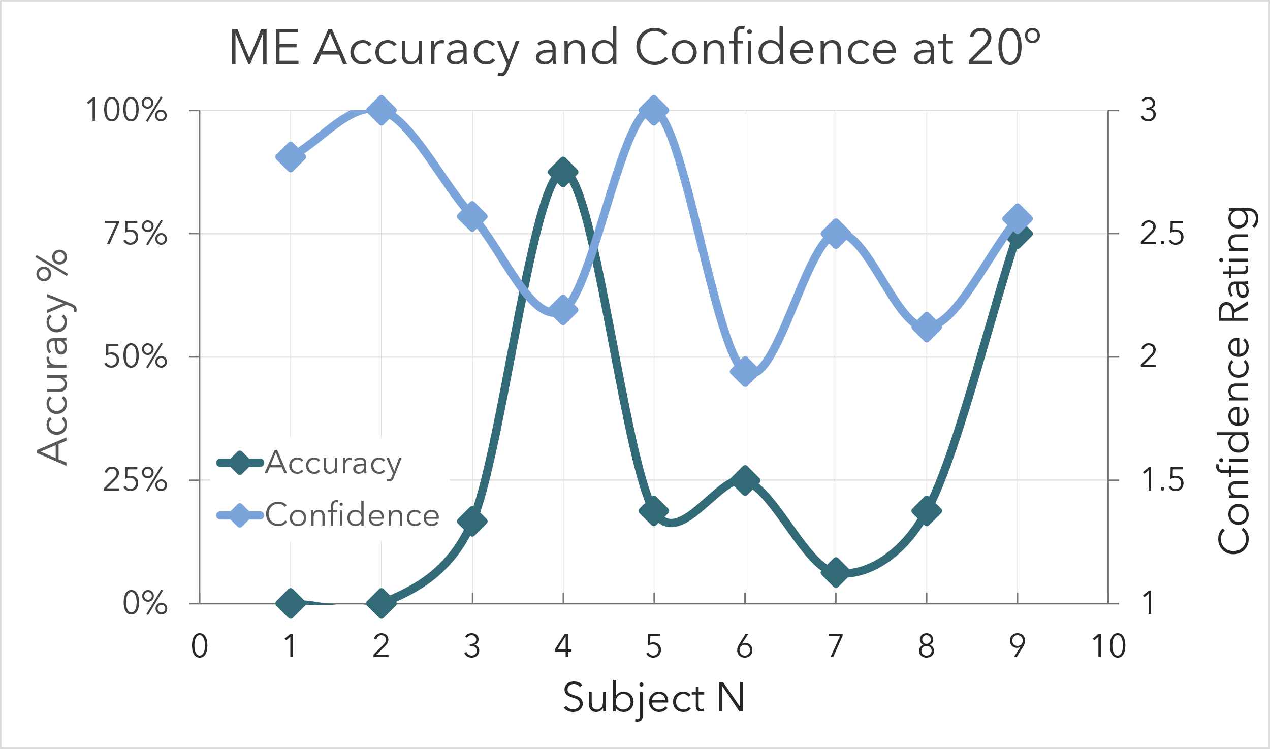

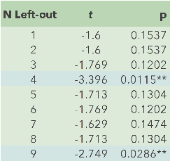All participants showed high confidence coupled with low accuracy. Except for participants 4 and 9.

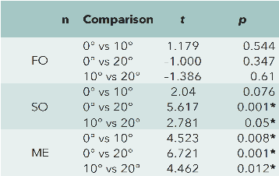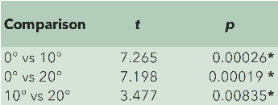One of the main takeaways is that conducting the same experiment on more subjects may have yielded better results.

Both eccentricity and motion type effects were significant in the experiment. This leads to a conclusion that biological motion perception declines with eccentricity for SO where form based spatial information is not enough and eyes need to focus on local motion cues. Since it is difficult to see local motion cues in the periphery, perception declines as well. As for ME, there is an assumption that having a strong inside X motion is enough to perceive, but weak Y motion is not enough, leading to possible misperception.

There is no significant difference between 0 and 10 degrees in SO as the form based spatial information is still intact and can be perceived. For ME, form based spatial information from 0 to 10 drops significantly.

# Discussion

Our findings reveal a distinct behavioral separation between first-order (FO) and higher-order (second-order – SO; motion-energy – ME) cues in the perception of biological motion, particularly in peripheral vision. FO walkers consistently performed near the ceiling across all eccentricities. Conversely, the accuracy for SO decreased by approximately 40 percentage points and for ME by about 65 percentage points from 0° to 20°, aligning with previous studies that reported diminished precision for contrast-defined motion (Gurnsey et al., 2010) and direction reversals at elevated temporal frequencies (Thompson, 2007). Importantly, the current experimental design maintained constant stimulus size and dot lifetime while enforcing eye fixation, thereby eliminating retinal-size artifacts and foveating strategies as potential explanations. The below-chance performance in ME at 20° suggests not random errors but a **genuine direction reversal**, consistent with a cue-conflict scenario where carrier motion overshadows the intended global trajectory. From a metacognitive perspective, confidence levels decreased in tandem with accuracy (r ≈ .9), indicating that observers recognized the unreliability of higher-order cues—this awareness is beneficial for interface design, as it allows users to self-correct when they are uncertain. Applications. In peripheral AR/VR environments, it is advisable to prioritize luminance-defined icons; contrast-modulated or texture-based markers may lead to misinterpretation. Clinically, this paradigm could be utilized to investigate peripheral deficits in conditions such as glaucoma or neurodegenerative diseases, where higher-order motion channels are frequently impaired.

# References

Aaen-Stockdale, C., & Thompson, P. (2008). Second-order motion is re-coded into first-order form before direction discrimination. Journal of Vision, 8(4), 1–13. https://doi.org/10.1167/8.4.2

Blake, R., & Shiffrar, M. (2007). Perception of human motion. Annual Review of Psychology, 58, 47–73. https://doi.org/10.1146/annurev.psych.57.102904.190152

Cavanagh, P., & Mather, G. (1989). Motion: The long and the short of it. Spatial Vision, 4(2–3), 103–129. https://doi.org/10.1163/156856889X00214

Gurnsey, R., Poirier, F., & Denmark, T. (2010). Perceiving biological motion from second-order cues. Vision Research, 50(24), 2201–2210. https://doi.org/10.1016/j.visres.2010.08.020

Ikeda, H., & Watanabe, T. (2005). Interaction of first- and second-order motion systems revealed by motion transparency. Vision Research, 45(18), 2223–2233. https://doi.org/10.1016/j.visres.2005.02.012

Johansson, G. (1973). Visual perception of biological motion. Perception & Psychophysics, 14(2), 201–211. https://doi.org/10.3758/BF03212378

Lu, Z.-L., & Sperling, G. (1995). The functional architecture of human visual motion perception. Vision Research, 35(19), 2697–2722. https://doi.org/10.1016/0042-6989(95)00025-U

Pointer, J. S., & Hess, R. F. (1989). The contrast-sensitivity gradient across the human visual field. Vision Research, 29(9), 1133–1141. https://doi.org/10.1016/0042-6989(89)90068-2

Thompson, P. (2007). Direction misjudgements at high temporal frequencies reveal limits of second-order motion processing. Vision Research, 47(22), 3284–3292. https://doi.org/10.1016/j.visres.2007.09.002